BLOCKCHAIN TECHNOLOGY

ASSIGNMENT-1

1. OPEN REMIX PLATFORM:

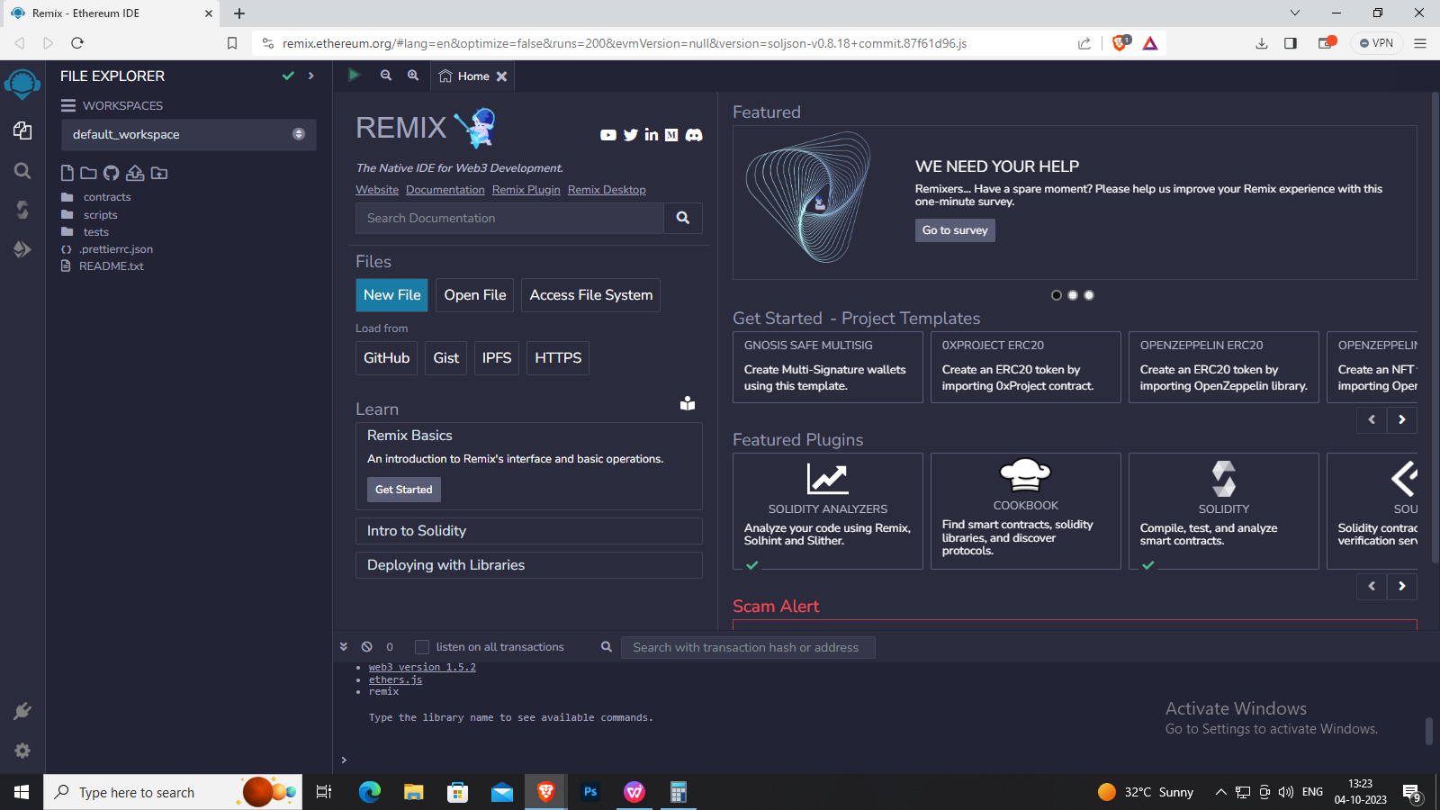

1. CREATE A NEW FILE IN REMIX PLATFORM:

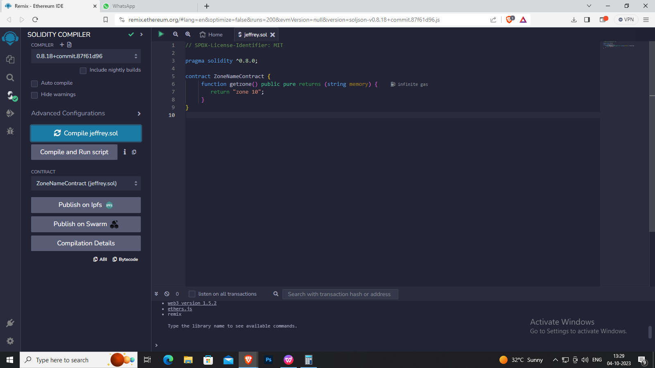

1. PROGRAM TO RETURN STRING:

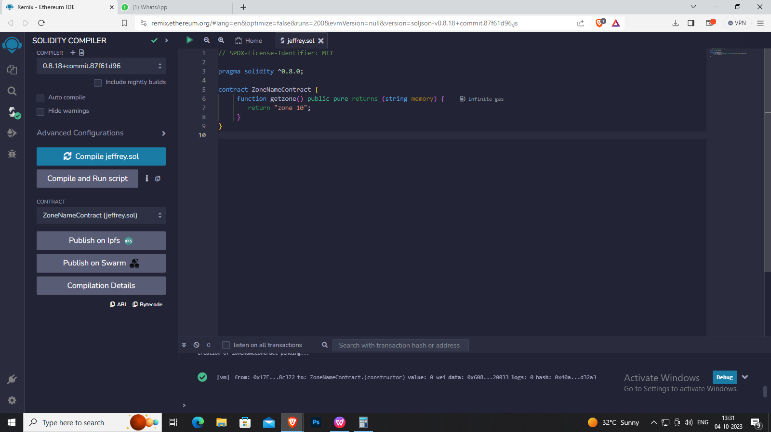

1. ABI AND BYTECODE:

ABI:

[

{

"inputs": [],

"name": "getZoneName",

"outputs": [

{

"internalType": "string",

"name": "",

"type": "string"

}

],

"stateMutability": "pure",

"type": "function

}

]

BYTECODE:

608060405234801561001057600080fd5b506101738061002060003 96000f3fe608060405234801561001057600080fd5b5060043610610 02b5760003560e01c8063235ed70f14610030575b600080fd5b61003 861004e565b604051610045919061011b565b60405180910390f35b 60606040518060400160405280600781526020017f5a6f6e65203130 0000000000000000000000000000000000000000000000000081525 0905090565b600081519050919050565b6000828252602082019050 92915050565b60005b838110156100c557808201518184015260208 10190506100aa565b60008484015250505050565b6000601f19601f8 301169050919050565b60006100ed8261008b565b6100f781856100 96565b93506101078185602086016100a7565b610110816100d1565 b840191505092915050565b60006020820190508181036000830152 61013581846100e2565b90509291505056fea2646970667358221220 761c0a81c7ac601bcefdd5738e950e478645f68698d5b4d19f6151a73 f050f5b64736f6c63430008120033

1. DEPLOY:

